**612/4**

**IPS ART & CRAFTS**

**Jul/Aug 2016**

**Paper 4**

**3 hours**

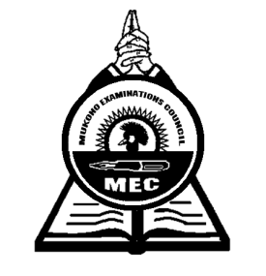

**MUKONO EXAMINATIONS COUNCIL**

**Uganda Certificate of Education**

IPS ART AND CRAFTS

Paper 4

**IMAGINATIVE COMPOSITION**

3hours

**Note:***Candidates must be instructed that* ***ruling*** *by all means whatsoever is* ***forbidden*** *except only when marking off space for name, index, number and center number.*

The Art Teacher should supply the candidates with cards measuring 5cm wide and 12cm long with which the candidates will demarcate the area on the top right-hand corner of the front surface of the paper. In this area, the candidates name, centre and index numbers, in that order, must be written clearly. This area **must not** be painted.

Candidates should be instructed that if work is painted, the relevant part of the background included. When working, candidates should bear in mind the positioning and the size of the figure on the space of the paper provided.

You are required to make an original composition based on one of the subjects given below. Bear in mind that quality of composition, feeling and originality are the main objectives of this paper.

Note:

* Composition **must not** be direct copies of other people’s work.
* Your picture should fill or approximately fill your sheet of paper.

**Subjects**

1. A School bash
2. Burial ceremony
3. A vehicle gets stuck in mud
4. A tight race at school
5. A visit to the game park
6. Gossiping
7. The shoe shiner
8. A culture dance

***End-***